Students were given the following instructions and grading rubric.

Step 1: Holding an 8 1/2" x 11" paper horizontally, fold both ends in so they meet, but do not overlap.

Step 2: Draw, color, and label the outside left flap as a plant cell and the outside right flap as an animal cell
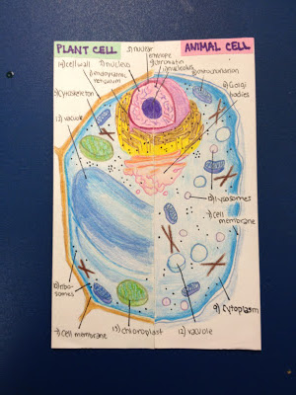
Step 3: With your paper flat (flaps open), you will have three sections formed by your folds. The far left section will be for plant cell differences, the far right section for animal cell differences, and the center for similarities between plant and animal cells. In each of these sections, cell organelles will be listed and defined.
