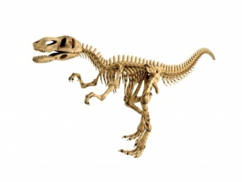
Fossil Research
Name:

http://www.enchantedlearning.com/subjects/dinosaurs/dinofossils/index.html
- What are Fossils?

- What does the word “fossil” mean?

- Most Fossils are excavated from what kind of rock?

http://www.zoomdinosaurs.com/subjects/dinosaurs/dinofossils/Fossilhow.html
- Why are fossils rock colored?

http://www.zoomdinosaurs.com/subjects/dinosaurs/dinofossils/Fossiltypes.html
- What are some common body fossils?

http://www.zoomdinosaurs.com/subjects/dinosaurs/dinofossils/Fossilfind.html
- Where have Fossils been found?

